Team Name: Macrohard Team Leader: Qi Zhenlin

Date: 2016.12.31

1 Prototype System Introduction

1.1 Functions

1. Reading sentences from file and allowing input and edit from keyboard.
2. Segmenting a text into sentences and allowing users to choose which sentences to segment.
3. Word segmentation.
4. Allowing users to help us improve the system by adding well-segmented sentences into our corpus.

Some other features:

1. We introduce a file named ‘configuration.ini’ to store the configuration, which makes users easier to change the setting without modifying the python code. Due to the limited time, I don’t have enough time to design a setting menu.
2. A log file (‘CWSS.log’) is enabled to record most of the users’ behaviors, so that when a bug occurs, we can browse the log file to find what’s wrong with the program.
3. We introduce a function called ‘Improve’ (a special menu is provided). If users find a segmentation is wrong, then they can correct it by clicking the ‘Improve’ menu. And the program will automatically import it into the lexicon. (NOTE: We have a checking mechanism which is especially designed to filter the completely-wrong segmentations that reported by users
4. A dynamic UI is performed, though it’s not very fluent. (We three debugged it for much time only to find it’s really a tough work to solve)
5. Multithreading & Multiprocessing: Multithreading is used at the welcome interface so that the lexicon will be loaded even if we don’t click the welcome window. And Multiprocessing is used when the program is going to update the lexicon so that the window will always be responding for users.

1.2 Running Environment

Windows 7/8/10

Linux 4.6.2 or higher version

1.3 Developing Environment

PyScripter 2.5.3

Pycharm 2016.3.2

Sublime + python package

2 Task Allocation

User Interface : Mao Yong

Algorithm : Qi Zhenlin Shi Zheyu

Integration : Mao Yong

Instruction : Mao Yong

PPT : Qi Zhenlin

Lab Report : Shi Zheyu

Debugging and System Testing : All the members

3 System Architecture

The user interface is mainly made up by two frames, menu bar and the main operating area. There’re file, edit, segmentation, lexicon, help and improve menus. Below there’re sub-window that displays file context, sentences taken apart and the result (the main function).

For more detailed information, please see the screenshots in section 5.1.

4 Algorithm Description

Tag the training corpus by 4-tag

Train the HMM model

Figure out transition matrix and pi matrix

Result

Tag the sentence by the trace

Use trained HMM model to find out the trace with the greatest possibility

Figure out two-char confusion matrix

Figure out confusion matrix

Our algorithm is based on HMM model. It contains three matrices(transition matrix, confusion matrix and two-character confusion matrix) and one vector(pi vector). We use training corpus to train our model.

4-tags “B” “M” “E” “S” stands for beginning, middle, ending, and single. Then the segment task can be transformed to find out the hidden tags behind every character in the sentence.

“delta” is a two dimension array whose first index stands for the present character’s position in the sentence and second index stands for the character’s hidden state.

max { delta[i-1][k]*transition_matrix[k][j]*

two_char_confusion[k][sentence[i-1: i+1]] } , i > 1

delta[i][j] =

max { pi[j]*confusion[j][sentence[i]] } , i = 1

Note that we are not only using sentence[i] to figure the possibility. It’s a improvement to the pure HMM model. In our model, the present character and last character are considered together. For example,

我们去公园玩。

我们 去 公园 玩 。

B E S B E S S

So when we count, it’s like: (‘E’, ‘我们’), (‘S’, ‘们去’), (‘B’, ‘去公’), (‘E’, ‘公园’), (‘S’, ‘园玩’), (‘S’, ‘玩。’).

This improvement brought great increasing in precision.

We also used log() to reduce the cost of computation of the possibility.

To specify, Qi Zhenlin and Shi Zheyu communicated about algorithms, and thought about means to improve it together, but our programs are finished respectively. There is a difference in our algorithms when training the matrix. Qi’s algorithm consider those two-character combination that appeared 10 times or more as ‘frequent combination’, and they will arise a higher possibility than other combinations. And Shi put them all into matrix. Comparing two algorithms, Qi’s can learn some words quickly, but also easier to get affected when the corpus is not much average.

5 Demo and Testing Result

5.1 Screenshots

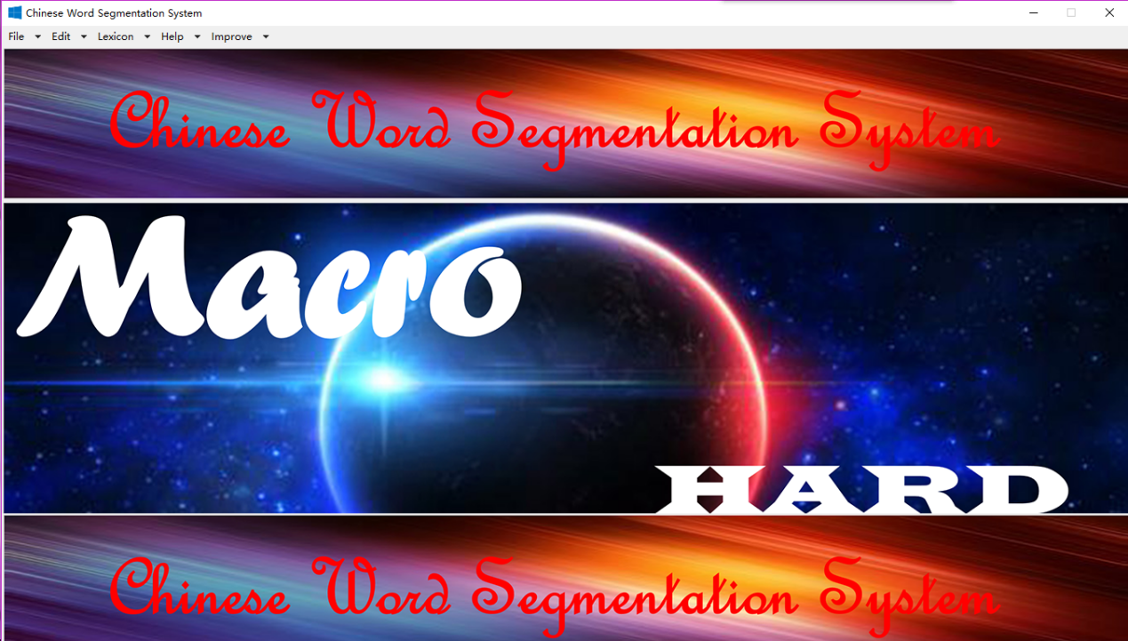

Main Screen

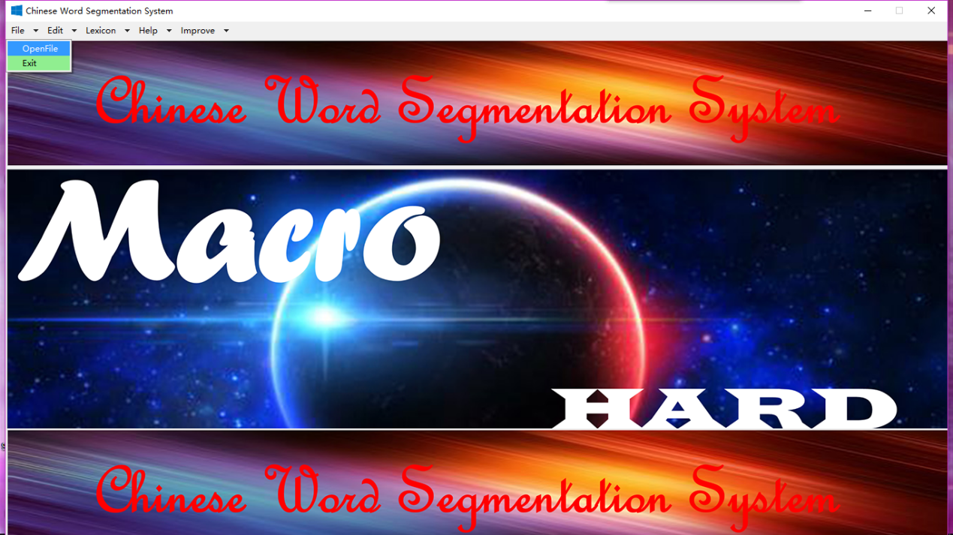

File Menu

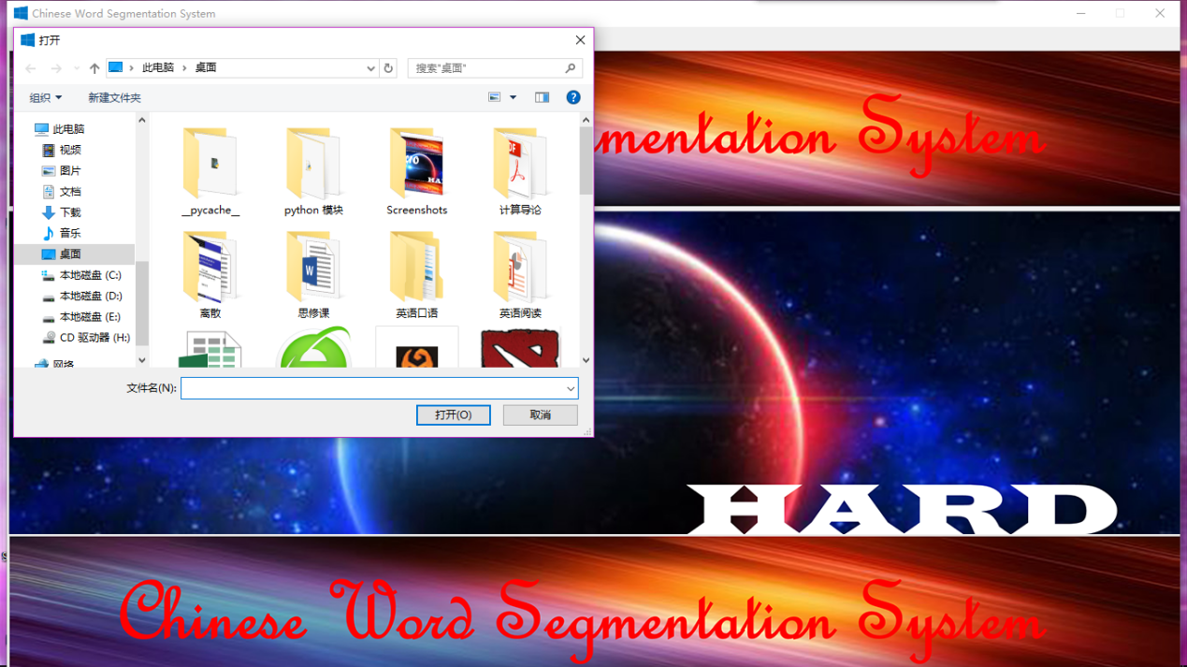

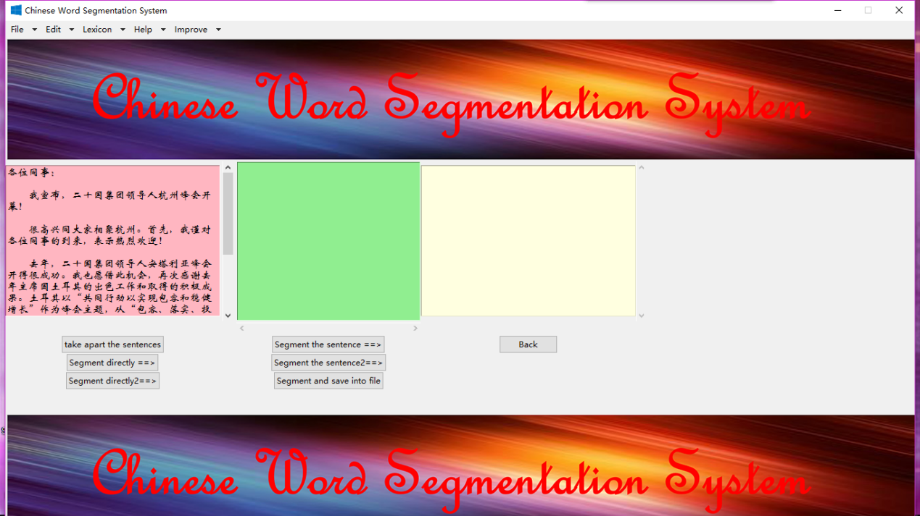

Openfile

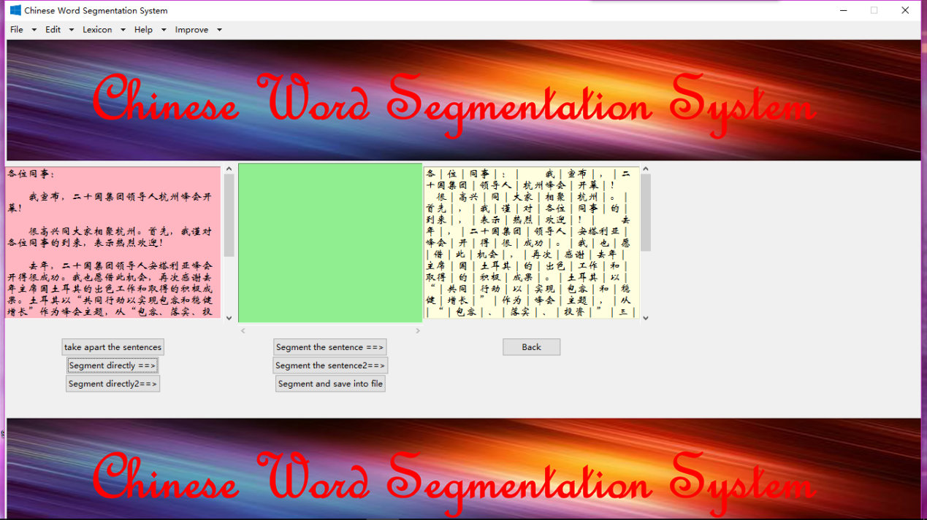

Segment directly

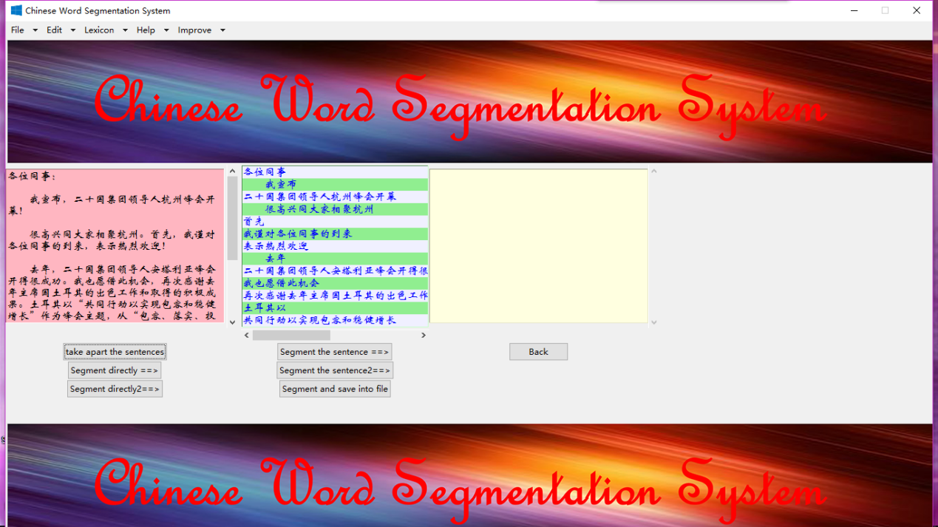

Take apart the sentences

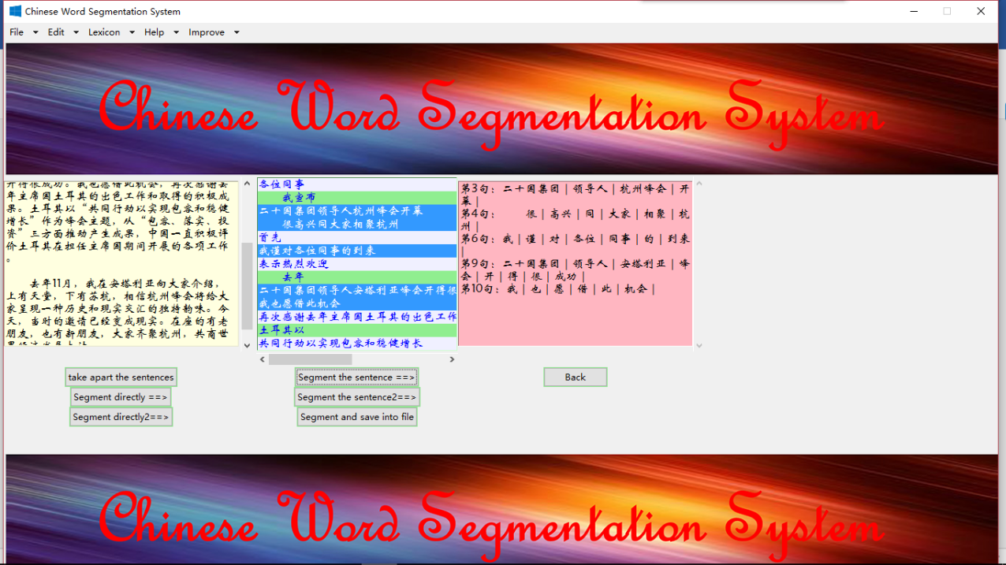

Segment chosen sentences

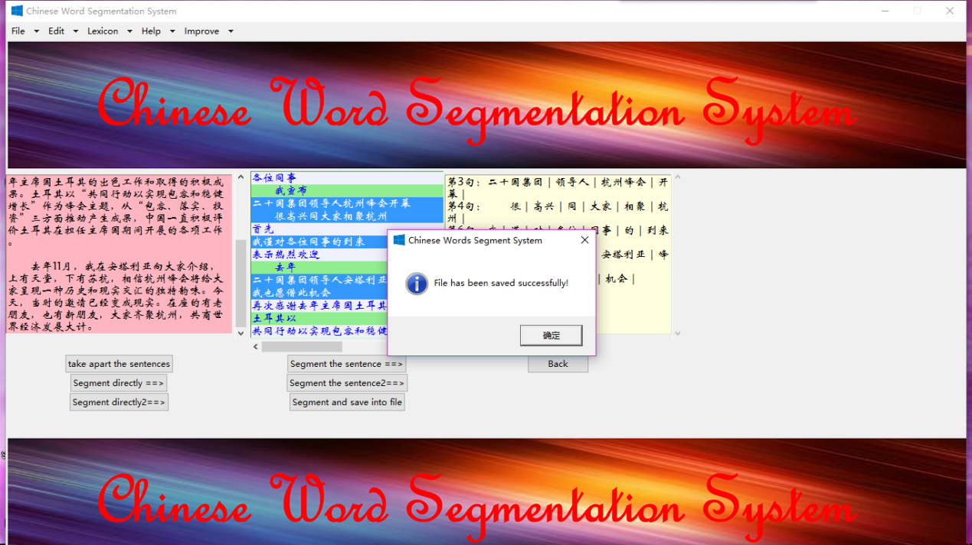

Segment and save into file

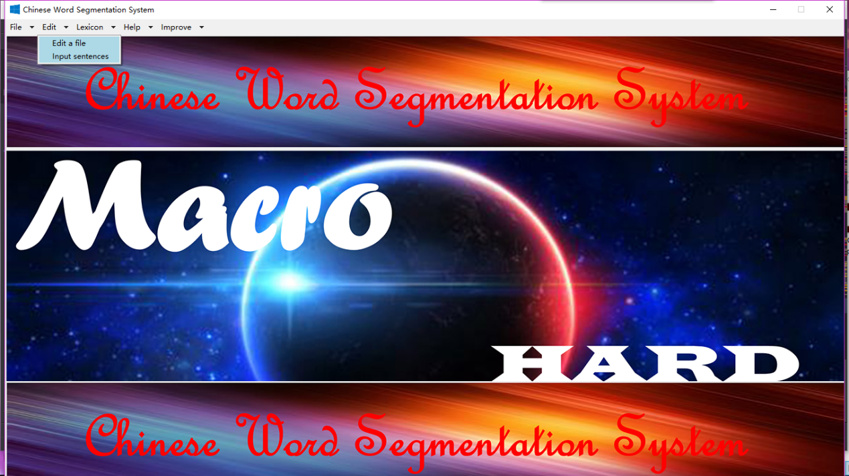

Edit

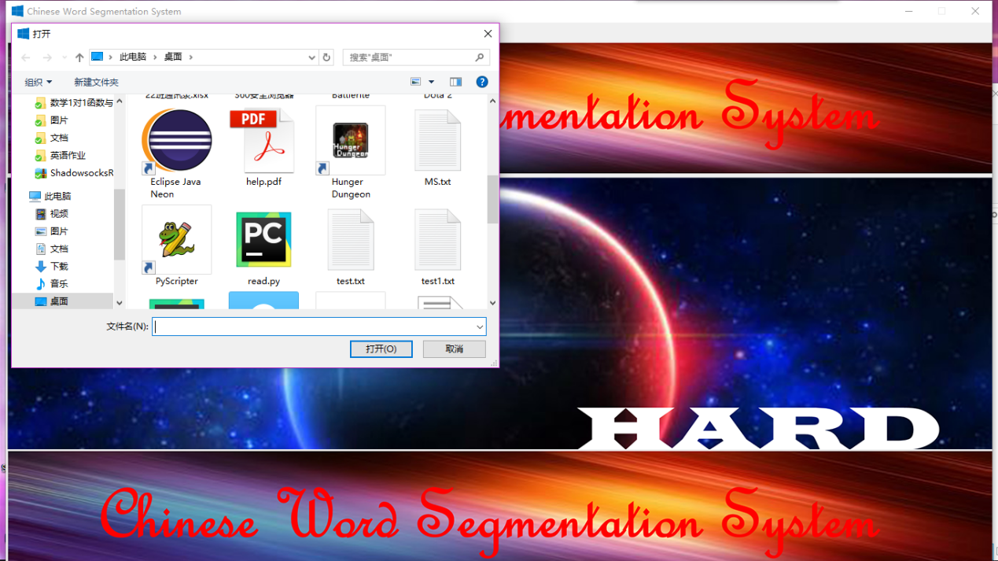

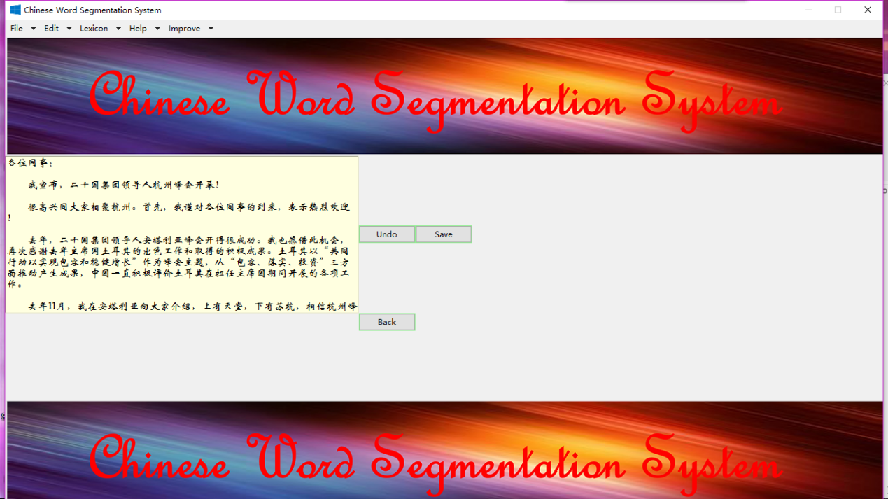

Edit a file

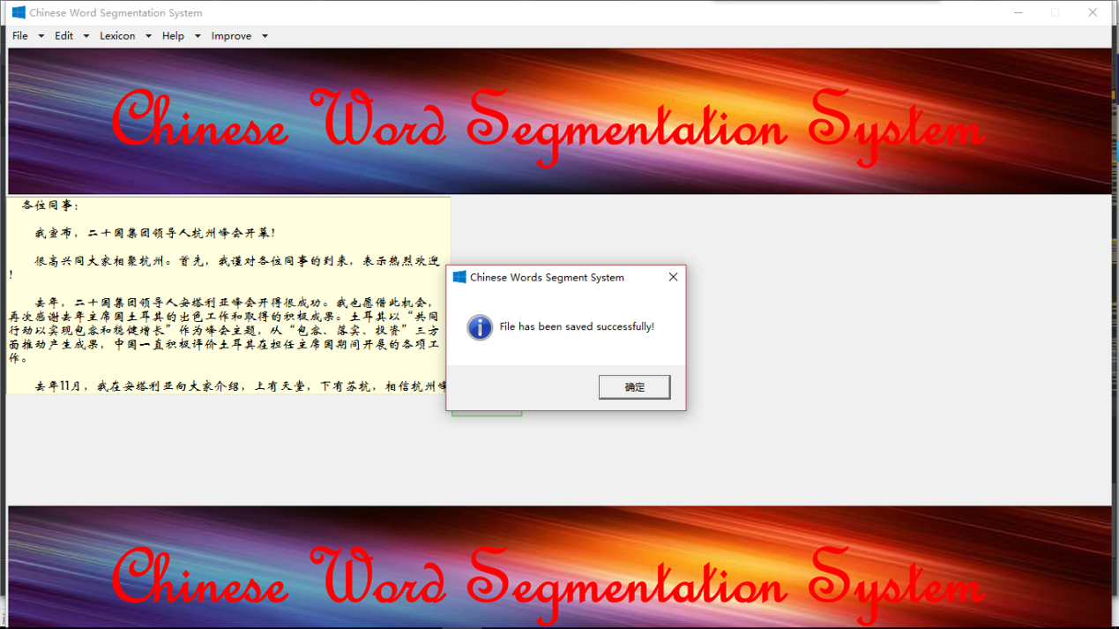

Save file

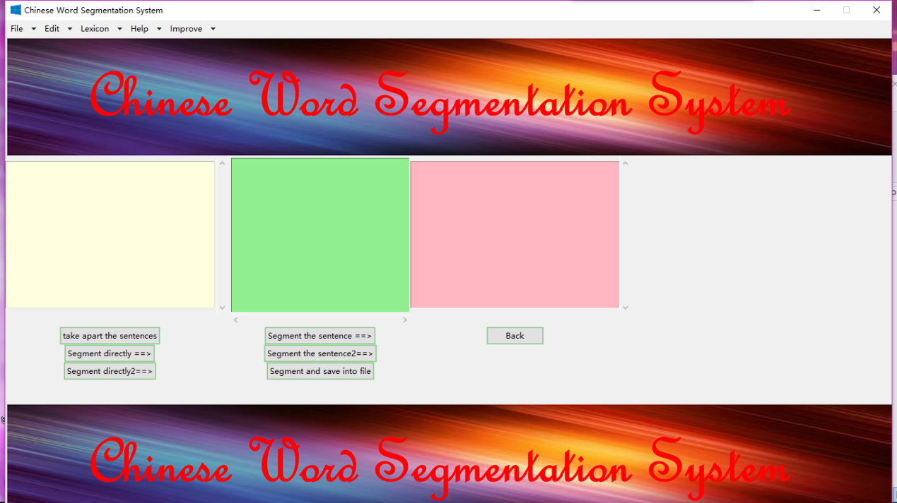

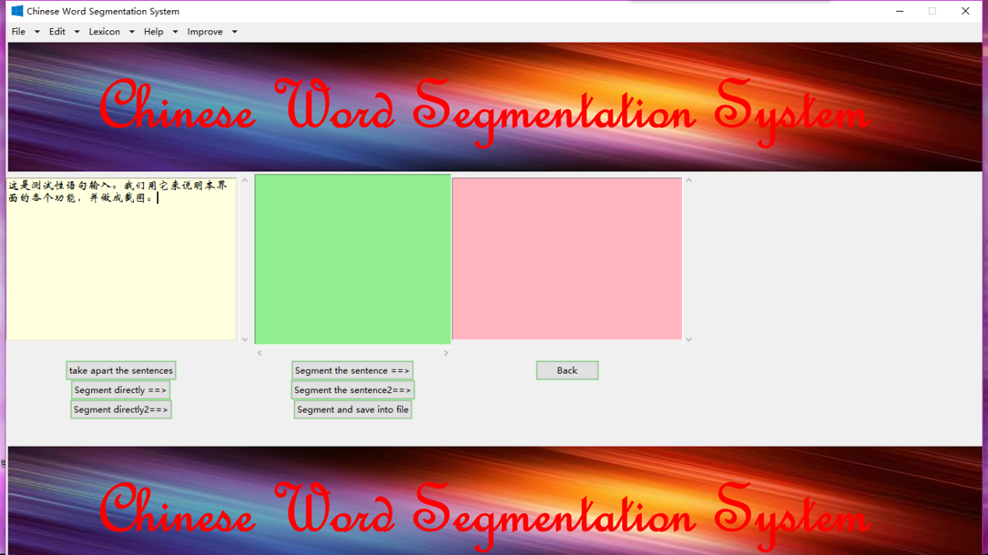

Input sentences

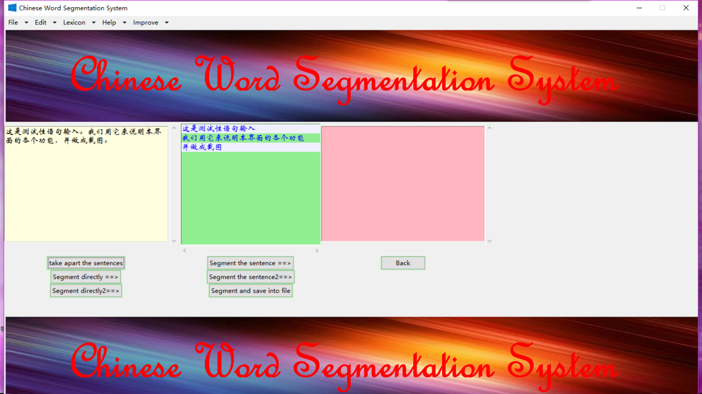

Take apart the sentences

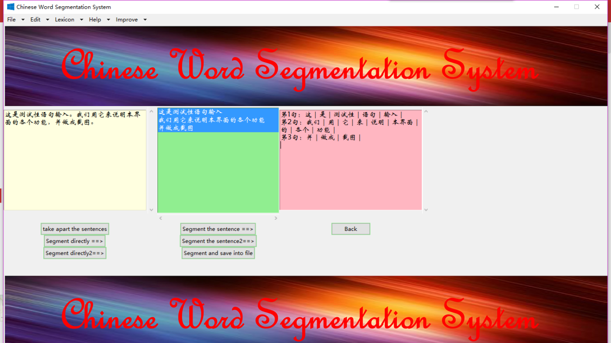

Segment the sentences

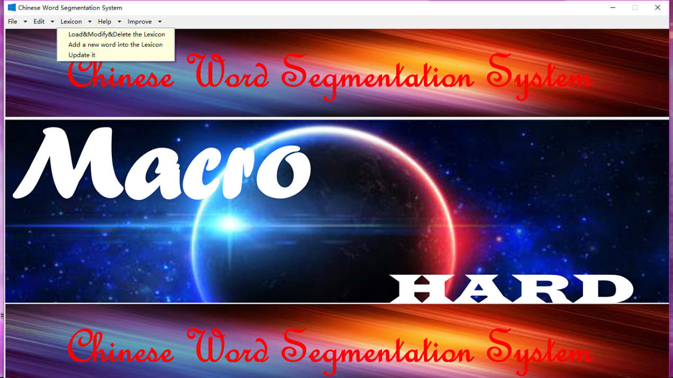

Lexicon

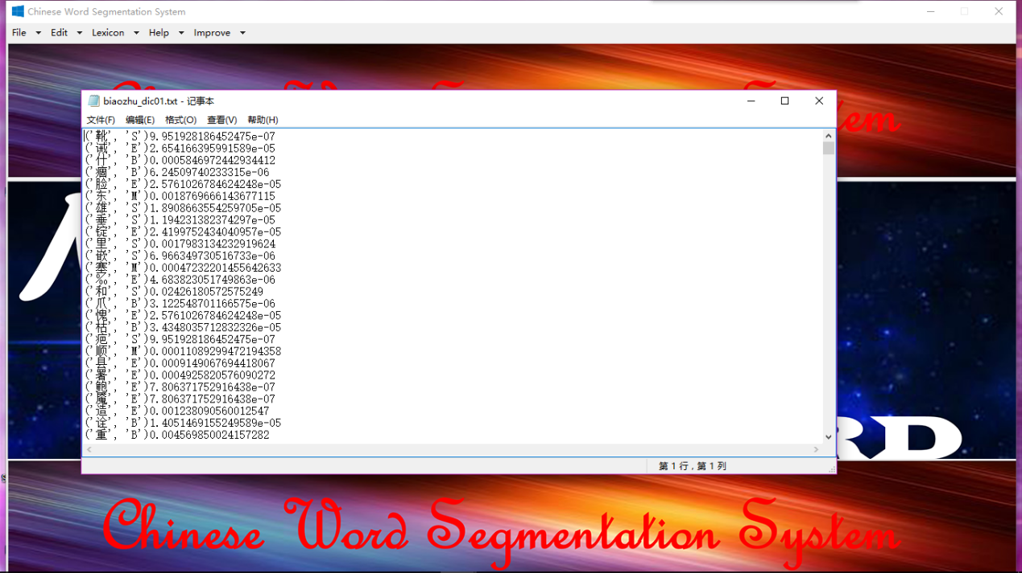

Load&Modify&Deletet the lexicon

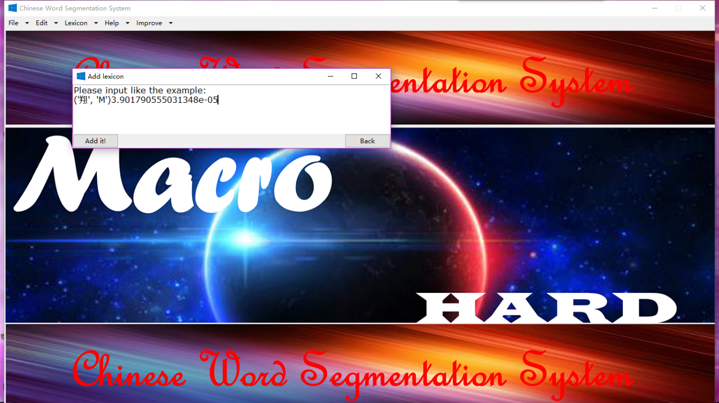

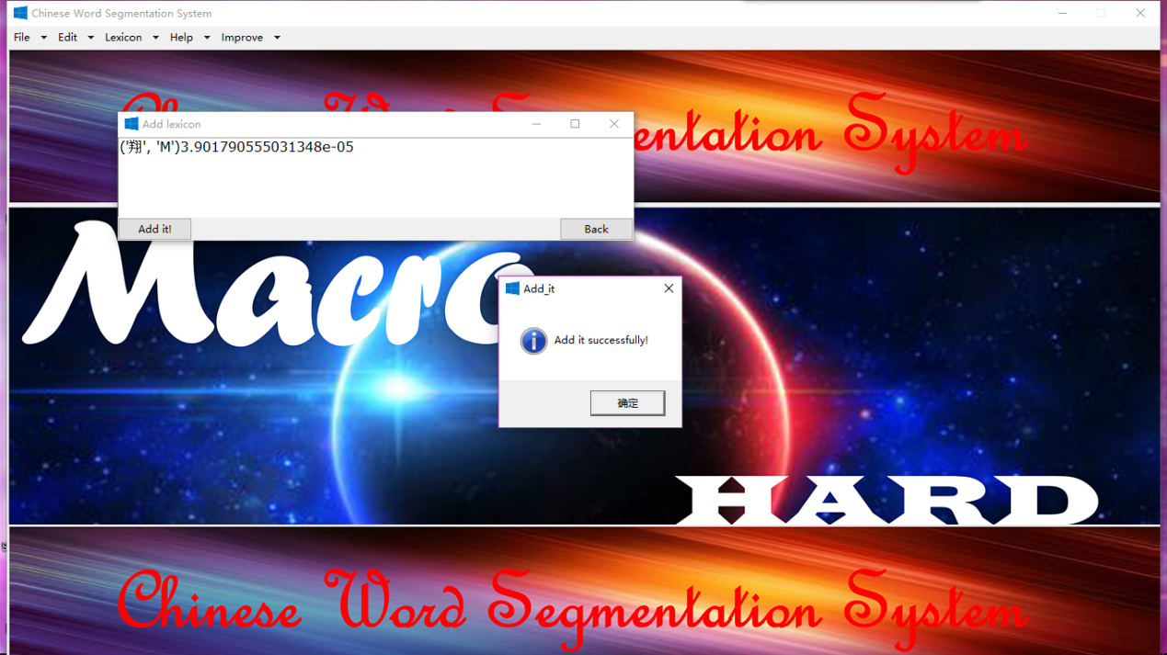

Add a new word into lexicon

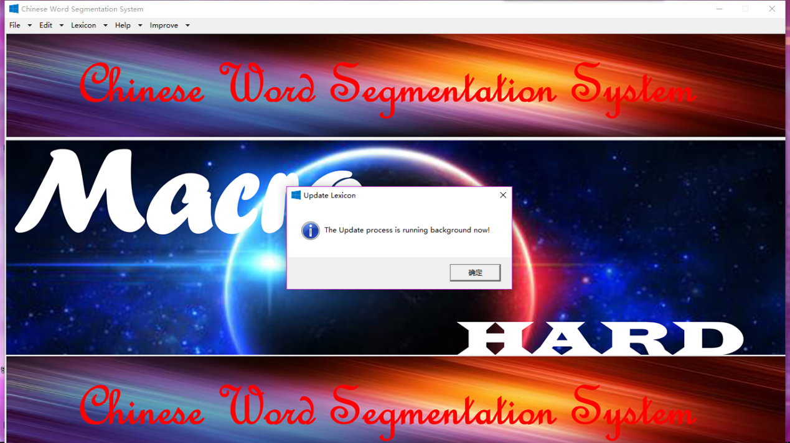

Update it

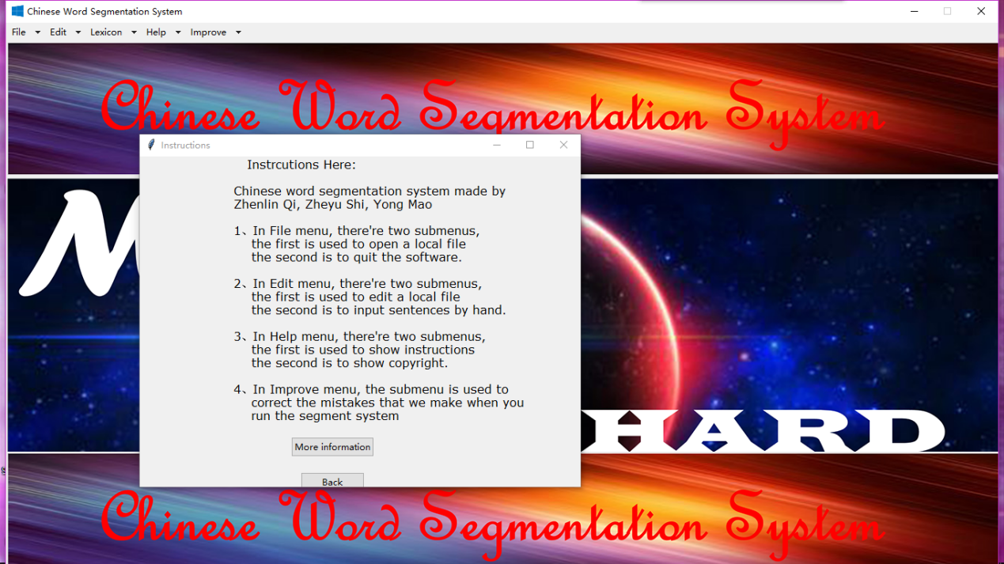

Instruction about the system

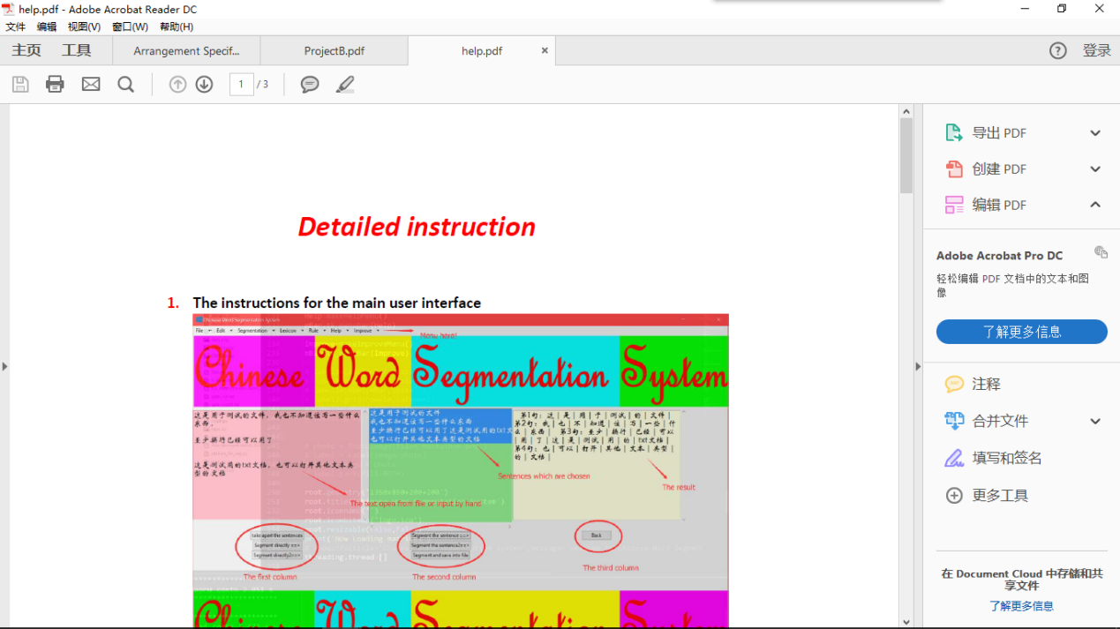

More information

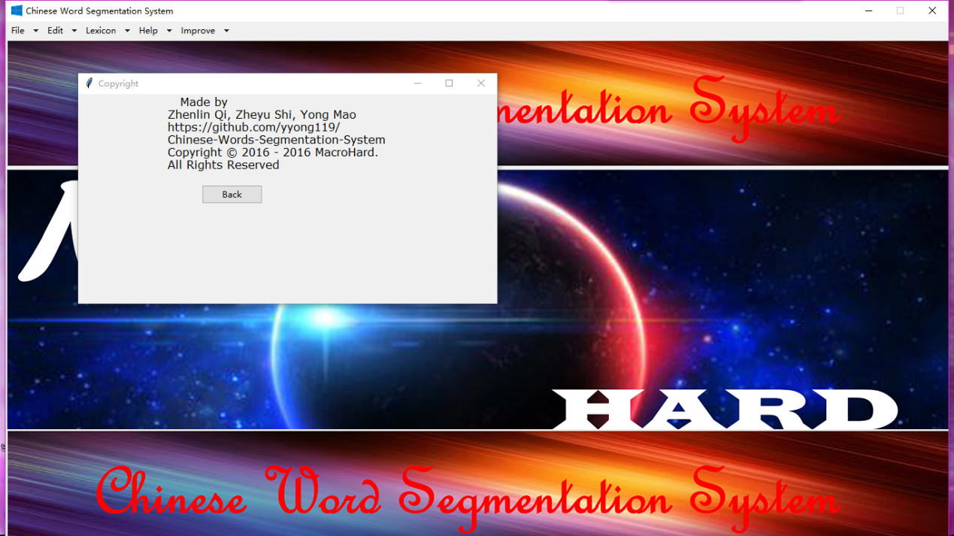

Copyright information

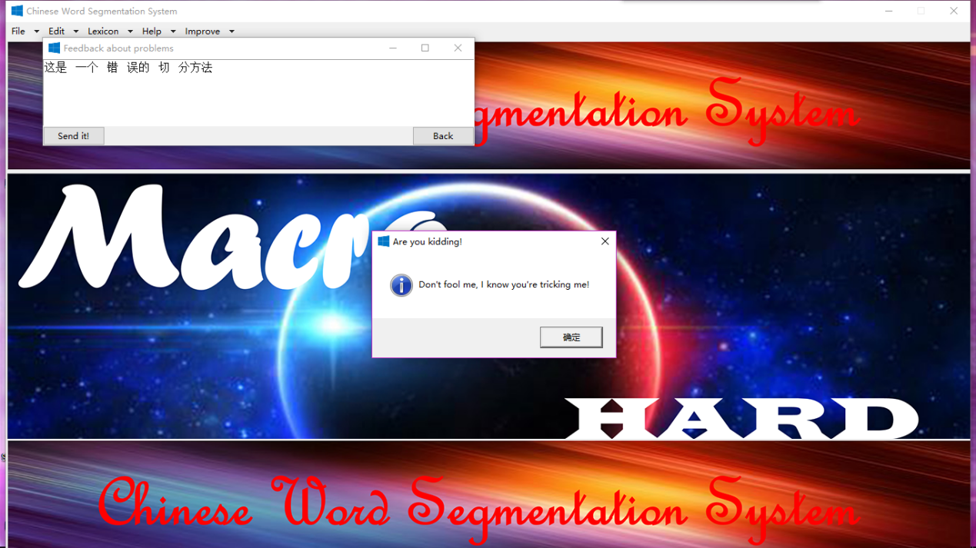

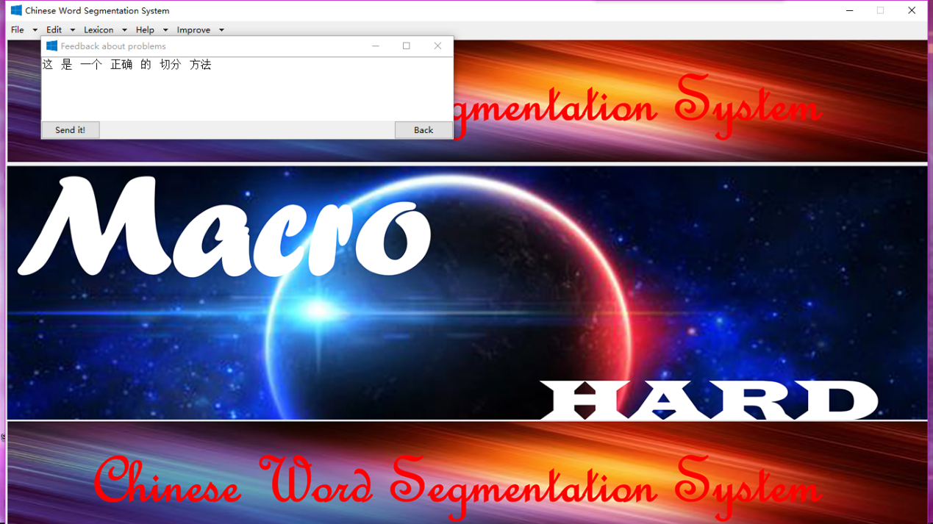

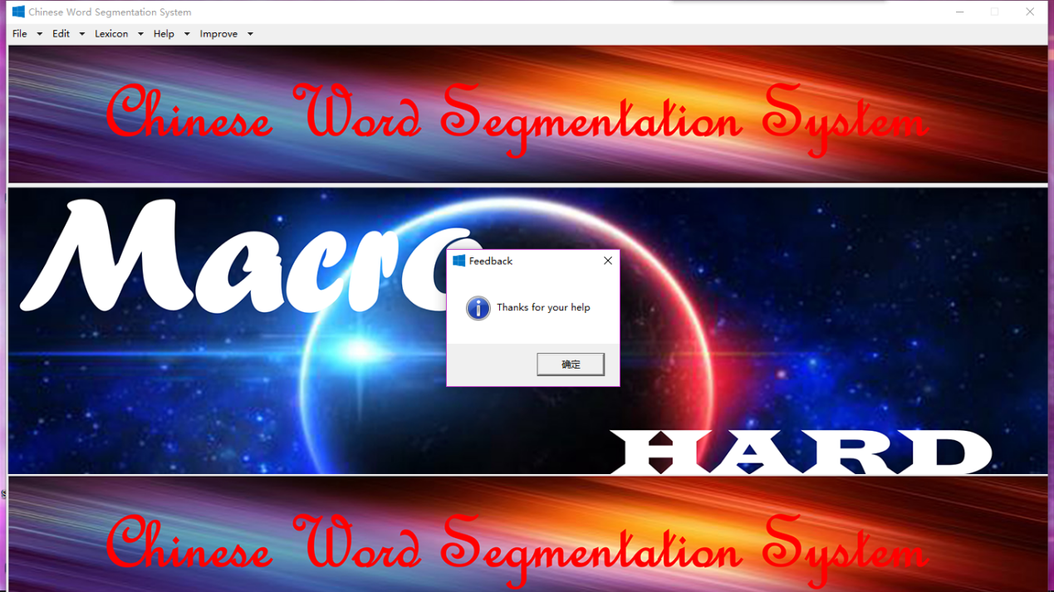

Improve

5.2 Testing Procedure, Data and Result

We used backoff2005 to test our algorithm, and msr_test_gold.utf8 to score our system.

Here is the result:

=== SUMMARY:

=== TOTAL INSERTIONS: 5722

=== TOTAL DELETIONS: 2816

=== TOTAL SUBSTITUTIONS: 8233

=== TOTAL NCHANGE: 16771

=== TOTAL TRUE WORD COUNT: 106873

=== TOTAL TEST WORD COUNT: 109779

=== TOTAL TRUE WORDS RECALL: 0.897

=== TOTAL TEST WORDS PRECISION: 0.873

=== F MEASURE: 0.885

=== OOV Rate: 0.026

=== OOV Recall Rate: 0.531

=== IV Recall Rate: 0.907

We also selected some sentences in <http://www.g20chn.org/> and segmented it by hand. Then we used our system to segment it then compared the result.

Here is the result:

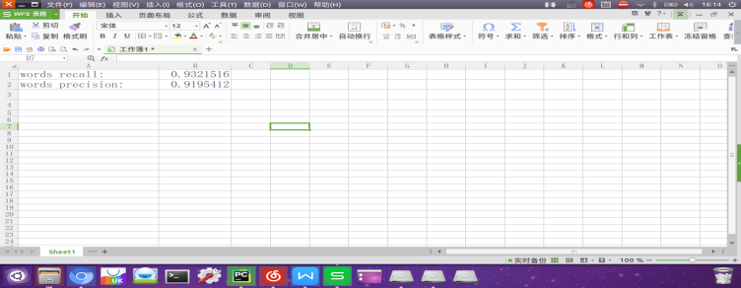

We consider this result reasonable. Since our training corpus is not huge, there is many unlisted words.

6 Conclusion

Our result is very inspiring and exciting, for we have achieved a satisfying result in the Chinese segmentation system. Our software has a good performance; also it has a great room for improvement. We do not expect our software is as perfect as the ones owned by giant company, but we really spend an enormous amount of hard work in it, because we want to try our best to achieve the first team project in university.

Through the process of completing this project, every member in our team has his own experience and acquaintance. In general, Mao Yong has a good overlooking of Tkinter, Shi Zheyu and Qi Zhenlin have some knowledge of algorithm in Chinese word segmentation, and all of us gain the basic ability to work as a team, which is really different with what we did in middle school.

All in all, we have not only improved our ability in programming, but also acquire the secret of how to achieve a good research.